**WELCOME TO A9– A WEBSITE DESIGNED USING**

**HTML AND CSS**

**A PROJECT REPORT**

***Submitted by***

**Harpreet Singh**

***in partial fulfilment for the award of the degree of***

# BACHELOR OF TECHNOLOGY

**IN**

## COMPUTER SCIENCE ENGINEERING



**Lovely Professional University, Punjab**

**12402475**

**NOVEMBER 2024**

# Lovely Professional University, Punjab

## BONAFIDE CERTIFICATE

Certified that this project report “Designing a website using HTML and CSS” is

the bonafide work of “Harpreet Singh” who carried out the project work

under my supervision.

**SIGNATURE SUPERVISOR**

**SIGNATURE**

**CLASS MENTOR**

**SIGNATURE**

### HEAD OF THE DEPARTMENT

**TABLE OF CONTENTS**

|  |  |  |
| --- | --- | --- |
| **S:NO** | **TOPIC** | **PAGE:NO** |
| 1 | Title Page | 1 |
| 2 | Bonafide Certificate | 2 |
| 3 | Table of Contents | 3 |
| 4 | Introduction of the Project | 4 |
| 5 | Technologies used | 5-7 |
| 6 | Workflow | 8 |
| 7 | Working of the Project | 9-10 |
| 8 | Code Snippets of the Project | 11-16 |
| 9 | Screenshots of the Project | 16-18 |
| 10 | Conclusion | 19-20 |

## INTRODUCTION TO THE PROJECT

The real estate market is undergoing rapid change, along with the demand for accessible, insightful, and user-friendly digital platforms. The purpose of this website was to offer a one-stop portal to homebuyers, investors, and architecture enthusiasts to obtain an excellent combination of property listings, architectural insights, and market analyses. The website has been created as a visionary and client-centric model that is set to make users capable of informed choices.  The site has interactive features such as virtual tours, complete descriptions of properties, as well as market trends from professional sources. This aims at filling the gap between property professionals and clients and an interactive experience to the needs of today's property market. This report will outline development, goals, and offerings unique to the website; hence, how it's a stand-out in this crowded space of real estate platforms.

## TECHNOLOGIES USED

The development of the urban star properties website utilized fundamental web technologies, specifically HTML and CSS, to create a visually appealing and functional online platform. Here’s a detailed overview of the technologies used:

### 1. HTML (Hyper Text Markup Language)

HTML is the backbone of the website, providing the structure and organization of the content. It is a markup language that uses a series of elements to delineate different parts of a webpage. Key elements of HTML used in this project include:

* **Structural Elements**: <header>, <nav>, <main>, <footer>, and <div> elements were used to define the layout and structure of the website. These elements help to organize content into logical section

s, making it easier for users to navigate.

* **Text Elements**: <h1> to <h6> for headings, <p> for paragraphs, <a> for hyperlinks, and <span> for inline text styling. These elements ensure that the content is readable and well-organized.
* **Media Elements**: <img> for images and <video> for videos. These elements were used to

include media files that enhance the visual appeal and user experience.

* Form Elements: <form>, <input>, <button>, and <select> for creating interactive forms. These elements enable users to submit inquiries and reservations through the website.

### 2. CSS (Cascading Style Sheets)

CSS is used to style the HTML content, controlling the visual appearance of the website. It allows for the separation of content (HTML) from design (CSS), making it easier to maintain and update the website. Key CSS features used in this project include:

* **Layout and Positioning**: display, position, flex, flex direction, and grid were used to create the overall layout and position elements on the page. Flexbox and Grid were particularly useful for creating good image adjustment.
* **Styling Elements**: Properties such as color, background-color, fontfamily(google poppins), font-size, margin, padding, border, and boxshadow were used to style text, images, and other elements, ensuring a co hesive and attractive design.

### Tools and Resources

* **Text Editor**: Code editors like Visual Studio Code was used for writing and editing the HTML and CSS code. This editor provide syntax highligh ting, code completion, and other features that streamline the development process.
* **Browser Developer Tools**: Builtin browser tools (e.g., Chrome DevTools, Firefox Developer Tools) were used for debugging and testing the website. These tools allow developers to inspect elements, view CSS properties, and test designs.
* **Version Control**: Git and GitHub were used for version control and collaboration. This allows for tracking changes, reverting to previous versions.

❖ The code is stored in the below mentioned Git hub repository

<https://github.com/sania991/sania>

WORKFLOW

Start



Project Planning



Providing HTML structure



Improving design by CSS



Adding other features



Adding various types of pages



Completing frontend of the website



End

## WORKING OF THE PROJECT

Our motive was to build a modern Real-Estate website designed using HTML and CSS operates seamlessly to provide an engaging and informative experience for its clients. Here’s an overview of how the website functions:

### Home Page

The home page serves as the entry point to the website, featuring an attractive and welcoming design. Key elements include:

* Background image (position absolute) is used to make it attractive

And logo of our site using the position relative properties. Multiple pages are linked by using the anchor tag

* Images are used to show the projects and upcoming projects.
* Media queries is used to make site responsive . On home page there are many buttons used to visit another pages.

**Navigation**

* Email , location and contact us options are there using the <ul> tag

**Our project page**

* Various images are used to show our projects.

### Interactive Elements

To enhance user engagement, the website includes interactive elements such as:

* **Hover Effects**: CSS hover effects are applied to buttons and images,

providing visual feedback when users interact with these elements.

* **Smooth Scrolling**: Smooth scrolling is implemented for anchor links, creating a pleasant navigation experience as users scroll through different sections of a page.

## CODE SNIPPETS OF THE PROJECT

**HTML:**

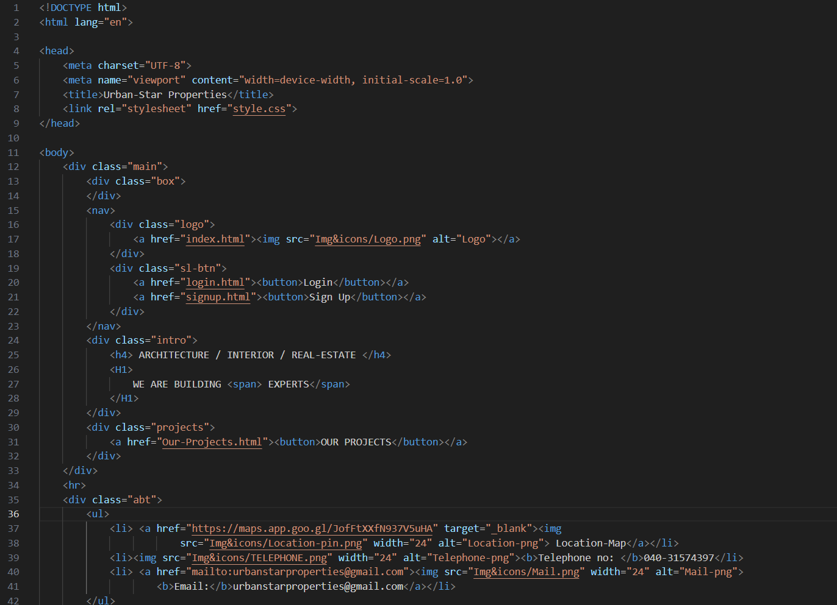

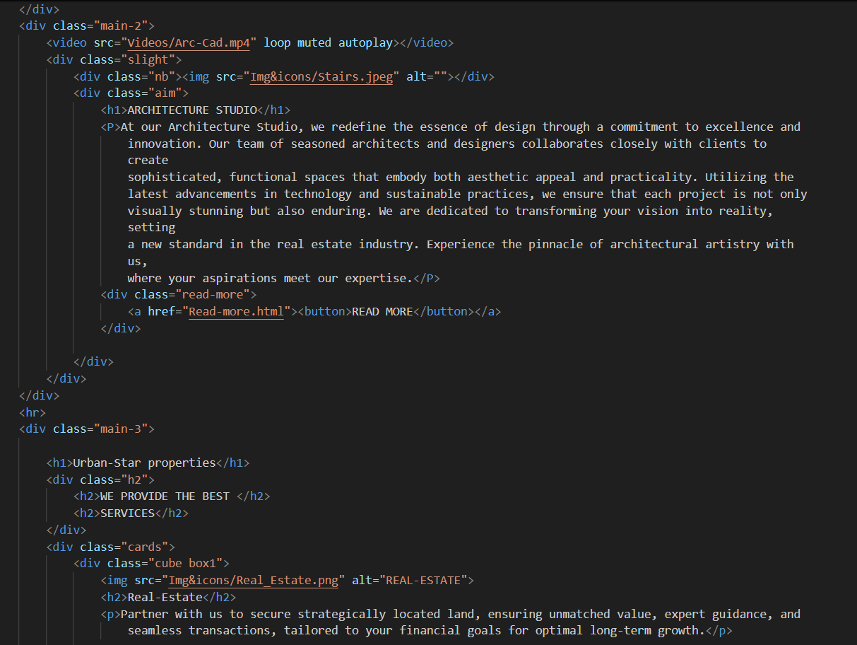

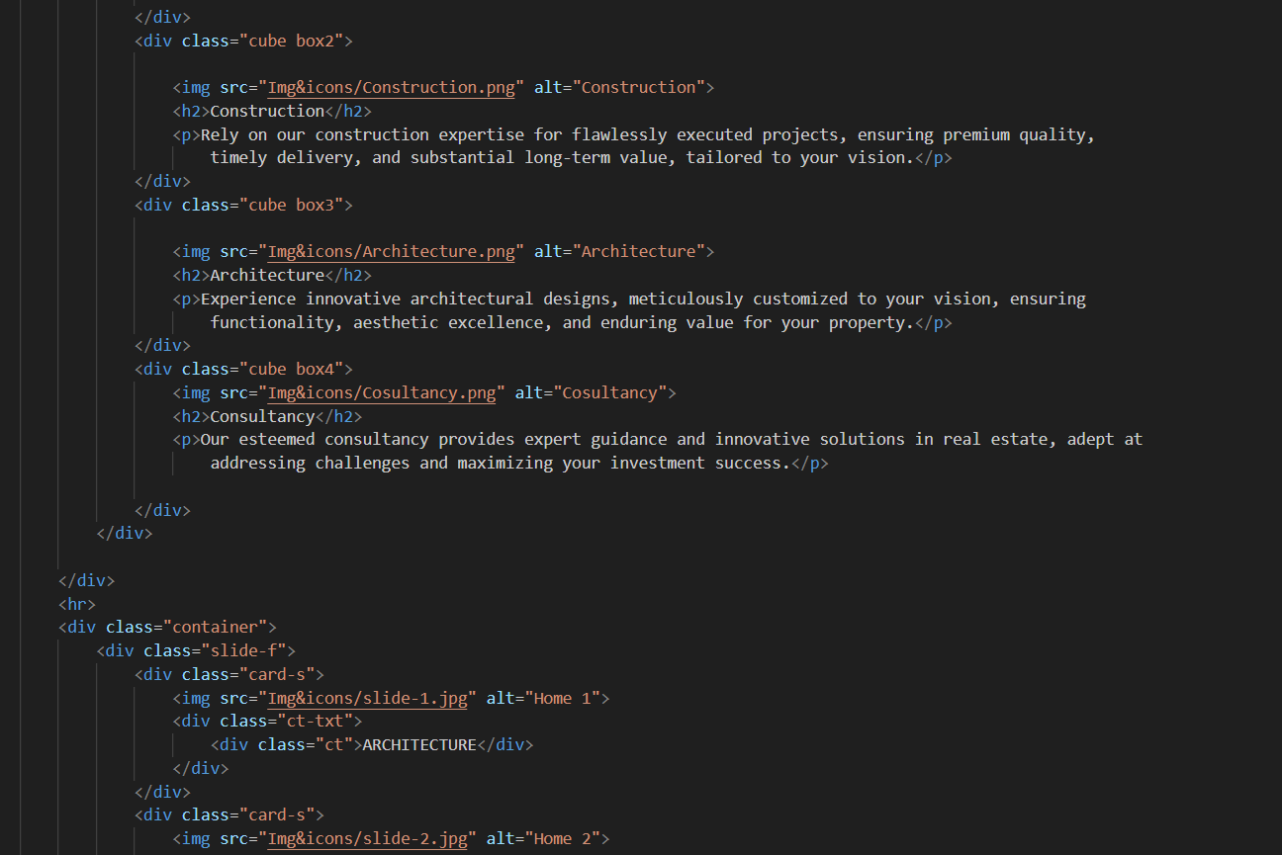

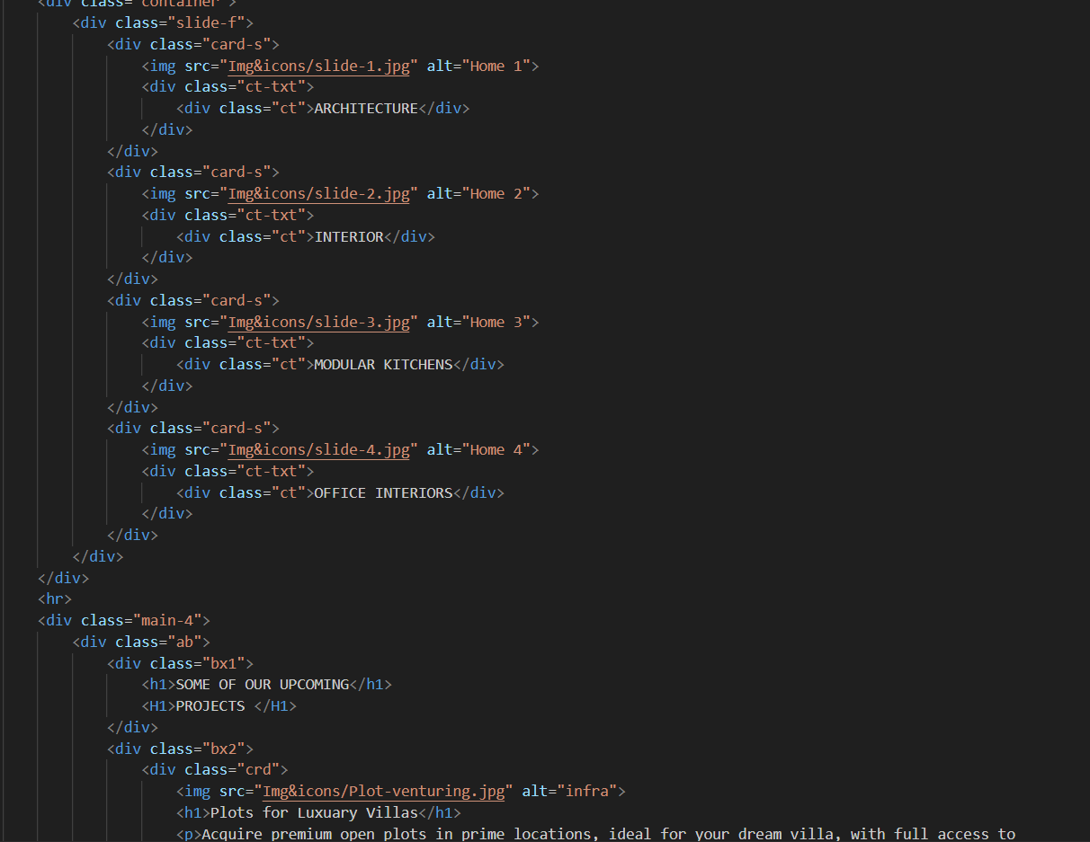

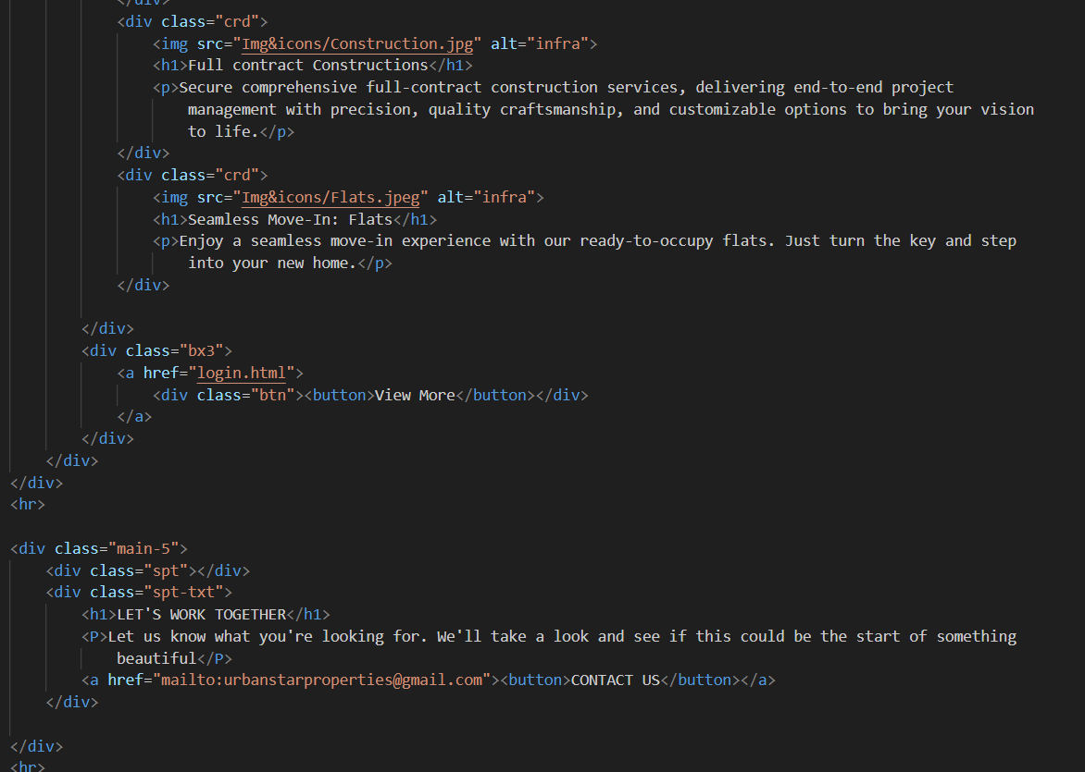

**CSS:**

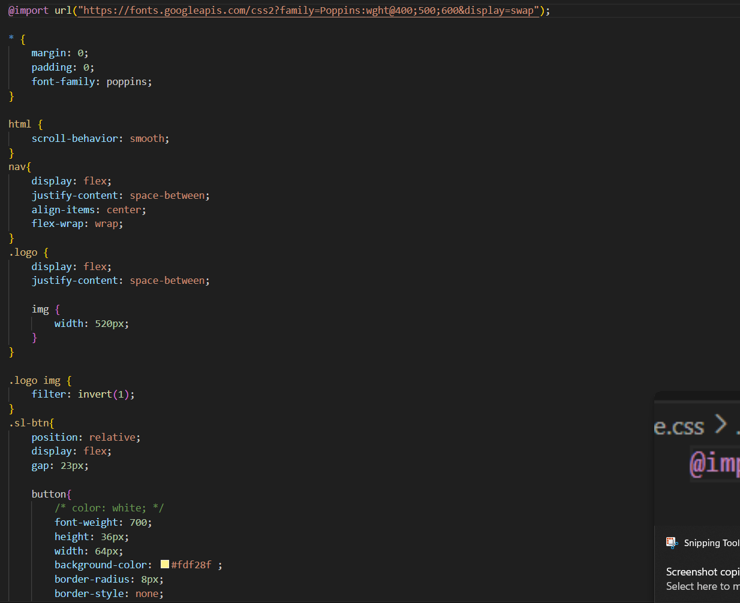

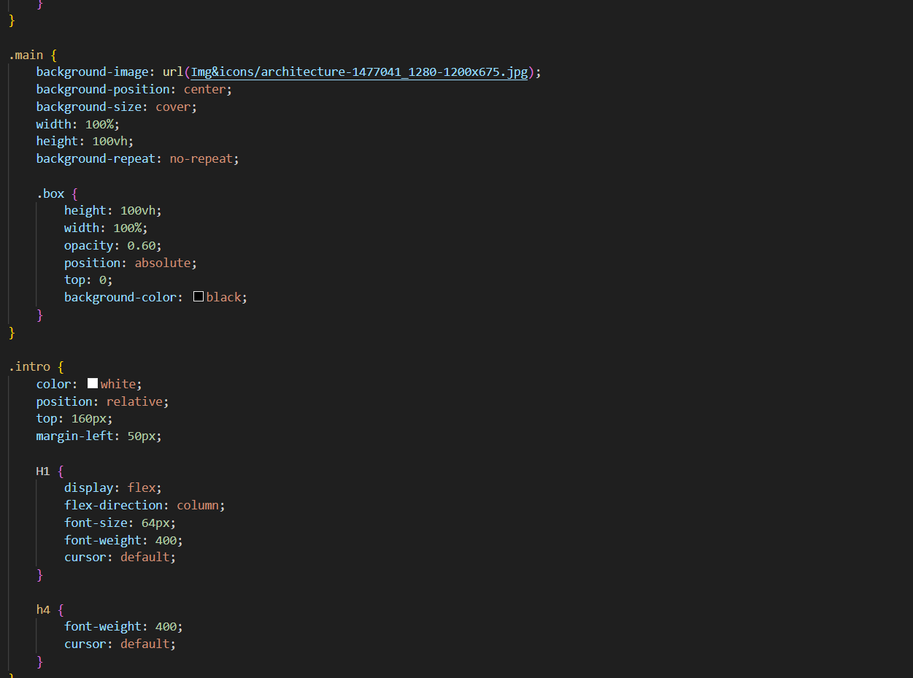

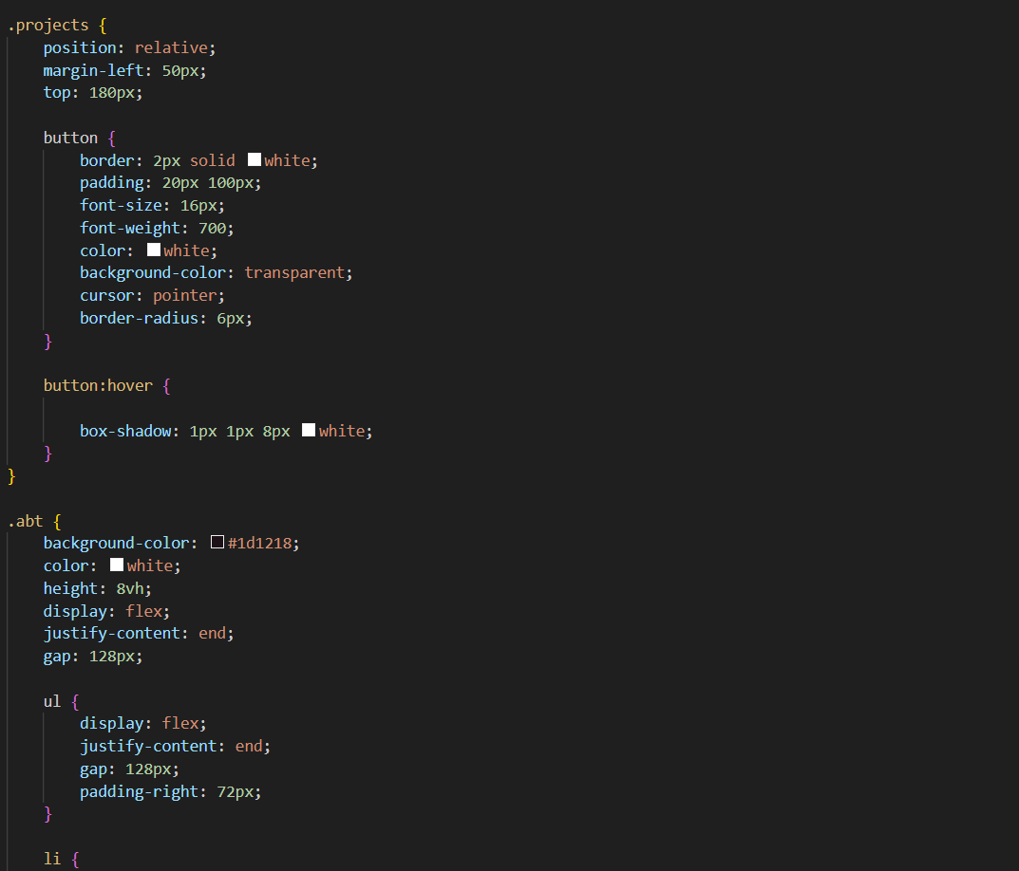

## SCREENSHOTS

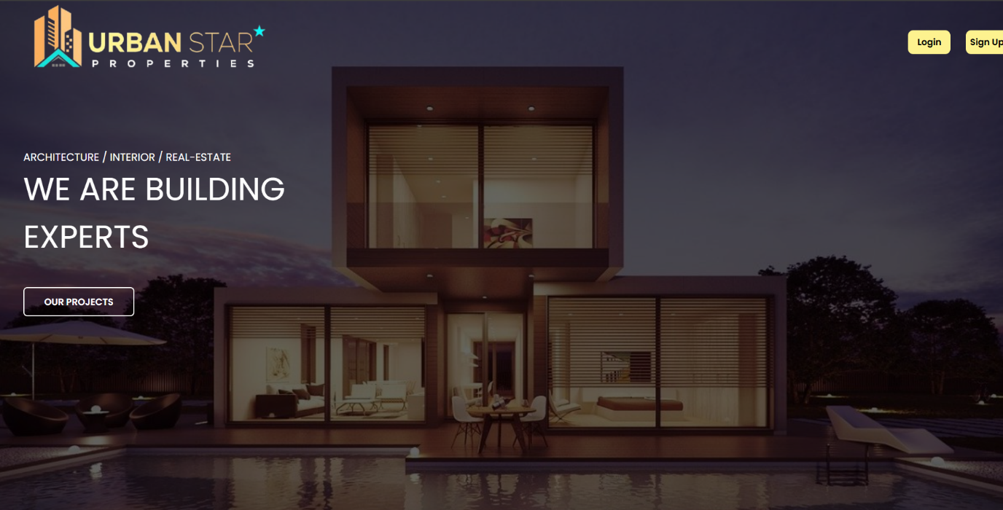

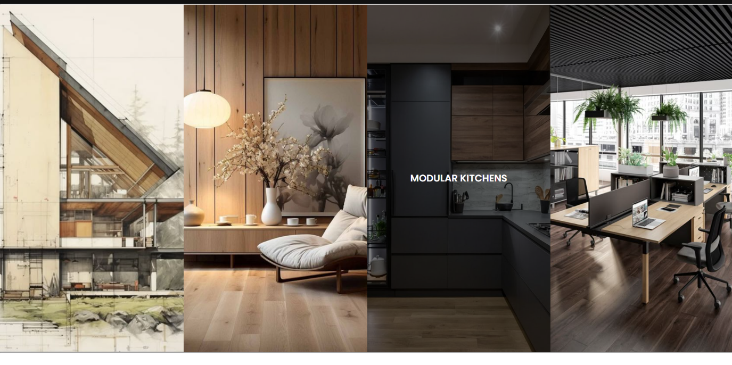

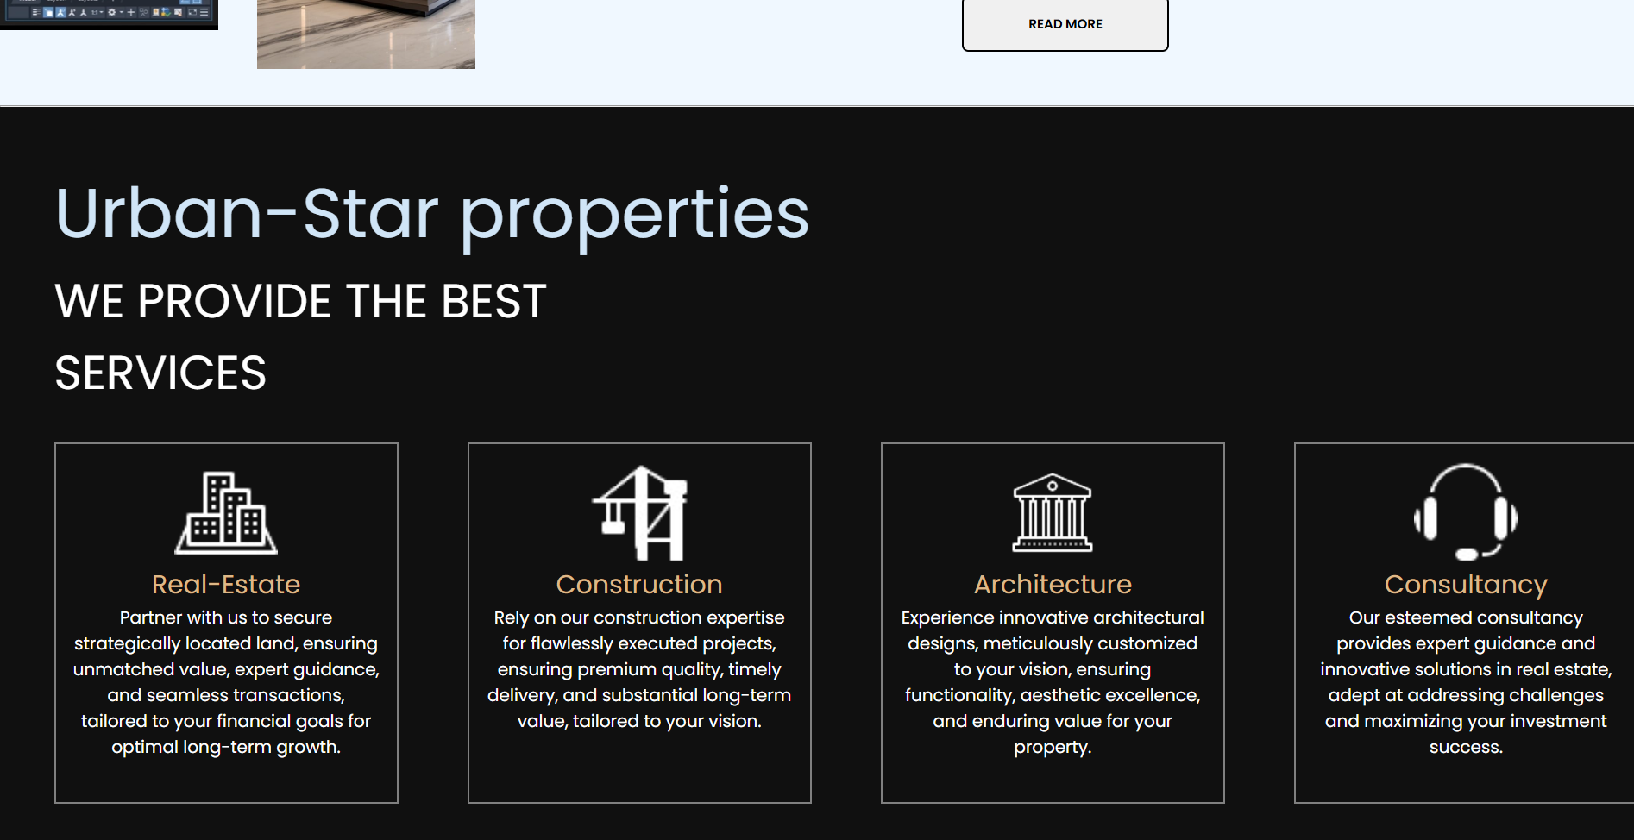

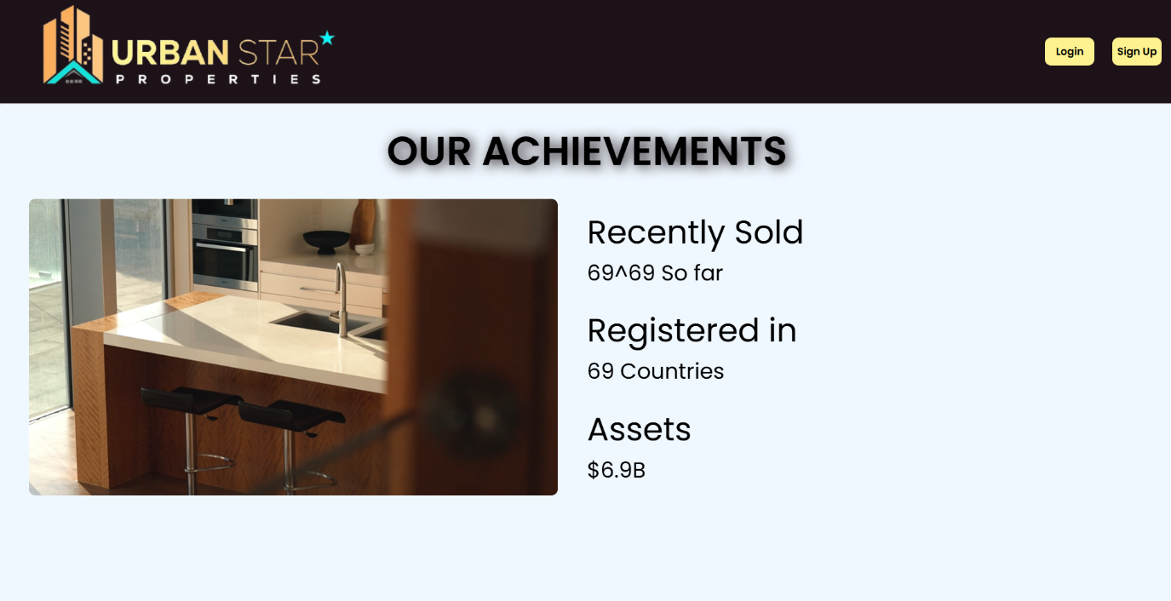

## CONCLUSION

In conclusion, I would like to thank the CSE326 faculty member “Arwinder Dhillon” for her assistance in completing the project.

The development of a real estate website using basic HTML and CSS demonstrates the power of fundamental web technologies in creating a professional, visually appealing, and user friendly online presence. The website effectively showcases the locations and venues of the flats,plots and houses, unique providing potential customers with essential information and an engaging platform to explore.

Through careful planning, design, and implementation, the project successfully integrates key features such as a welcoming home page informative and accessible contact information.

The project also highlights the importance of performance optimization, including image compression, minified CSS, and browser caching, to ensure fast loading times and efficient performance. By focusing on these aspects, the website not only attracts visitors but also retains their interest, encouraging further exploration and engagement.

Overall, this project serves as a foundational exercise in web design, illustrating how basic HTML and CSS can be utilized to create impactful digital platforms for businesses.

## REFERENCES

### W3Schools

W3Schools is an educational website that provides comprehensive tutorials and references for web development technologies. It played a pivotal role in the project by offering:

**Detailed Tutorials**: W3Schools provided step-by-step tutorials on HTML and CSS, covering everything from basic tags to advanced layout techniques. These tutorials helped in understanding the core concepts and implementing them effectively in the project.

**Extensive References**: The website’s HTML and CSS references were incredibly useful for quickly looking up specific elements, attributes, and properties. This allowed for efficient coding and ensured that the project

adhered to best practices.

**Interactive Examples**: The interactive code examples on W3Schools allowed for real-time experimentation and learning. This hands-on approach enabled the development team to test different styles and

layouts before applying them to the actual website.